MATH 3P40

Mathematics Integrated with Computers and Applications III

Final Project

Simulations of the Drossel-Schwabl self-organizing
critical forest-fire model

Matt Laidman
5199807
The discrete forest-fire model proposed by Drossel and Schwabl in [1] is defined as an N dimensional probabilistic cellular automaton, however has been studied in two dimensions in this case.

The model is an LxL lattice, where each cell is in one of three states:

- an empty site
- a green tree
- a burning tree

The lattice evolves as a probabilistic cellular automaton where each cell is updated simultaneously (using a parallel update) at each time step according to the following four rules:

- a burning tree becomes an empty site
- a green tree becomes a burning tree if at least one of the trees in its Von Neumann neighbourhood is a burning tree
- an empty site becomes a green tree with probability p
- a green tree without a burning tree in its Von Neumann neighbourhood becomes a burning tree with probability f
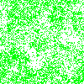Figure 1: A visualization of the forest

Figure 1 shows the model in a typical state where trees are green squares and empty sites are white squares. This specific image was created from a lattice of size 100x100 after 1000 fires had been burned with θ = p/f = 500.

Grassberger in [2] and [3] observed several power laws which exist in this model. Attempts at reproducing three of these results have been made. The three power laws which are investigated are:

- The mean fire lifetime of a fire T is proportional to θ^{0.5} for small θ. [2]
- The distribution of fire sizes N(s) is proportional to s^{1-τ}, τ ≈ 2.15. [3]
- The distribution of tree cluster sizes M(s) is proportional to s^{-β}, β ≈ 2.15. [2]

Simulations

As discussed by both Drossel and Schwabl in [1], and Grassberger in [2] and [3], critical behaviour is observed in the limit f « p « 1, and the only relevant parameter to the model is θ.

As in [2], the model is studied in this limit specifically when p is sufficiently small so that the growth of trees can be neglected while a fire initiated by a typical lightning strike burns. In this case, a fire can be viewed as an independent event from any other fires. The model is modified so that a given fire will burn in its entirety before any new trees are grown and any other trees are ignited by lightning. After a fire is burned out, exactly θ attempts at growing new trees are made on the lattice. A tree is then selected again at random to be ignited by lightning.

This modification can be made because a cluster of trees is burned down in its entirety by a lightning strike without interference from any other cluster as p is small. Trees which will connect clusters are not likely to grow.

For the simulations, we use the Mersenne Twister pseudorandom number generator as implemented in the C++11 standard template library. All simulations used a lattice size of 1024x1024. Periodic boundaries were used in all cases.

The fire is burned using a breadth-first iterative method in all cases, and a depth-first recursive method was use for counting the cluster sizes in the third simulation.

For the first simulation, 11000 fires were burned on five different values of θ = {500, 1000, 1500, 2000, 2500}. The first 1000 fires were ignored. The length of each fire was recorded and this was averaged across the remaining 10000 fires. The mean fire lifetime was plotted against θ, and the results can be seen in figure 2.

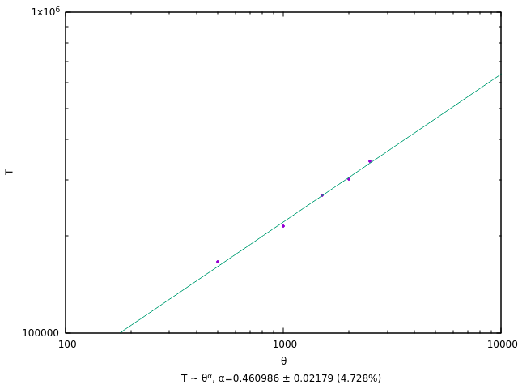Figure 2: Mean fire lifetime verses θ.

Figure 2 very clearly shows that the mean fire lifetime is in fact
proportional to θ and the exponent likely is in fact 0.5. Simulations only for relatively small values of θ were possible due to the time required to run them.

Though this is the expected value, Grassberger notes in [2] that this value does not hold for large values of θ. Instead, the expected value for the exponent is 0.87 ± 0.03.
For the second simulation, 100 simulations of 2500 fires were done and the first 1000 fires in each simulation were ignored. The number of trees burned by each fire was tallied and the distribution was plotted. A θ value of 500 was used. This can be seen in figure 3, where N(s) is the number of fires of size s.

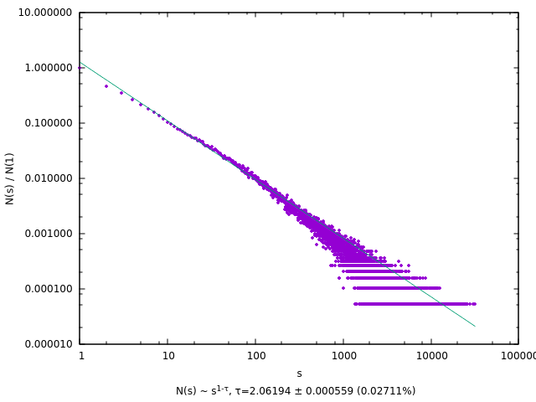Figure 3: Fire size distribution
The results obtained from this simulation, show that N(s) ~ s^{1-τ}, τ ≈ 2.06194 ± 0.000559 (0.02711%). This value is very close to the expected. It is likely that given enough simulations to average, this value would approach the expected value τ ≈ 2.15.

As fires burn exactly one tree cluster in its entirety, it is expected to see a power law in the distribution of tree cluster sizes as well. This can be seen in figure 4, where M(s) is the number of clusters of size s.

To produce these results, five simulations using 2500 fires and ignoring the first 1000 results were performed. The distribution of clusters was reported immediately before a lightning strike. This distribution was averaged over each of the 1500 fires, and again over each of the five simulations.

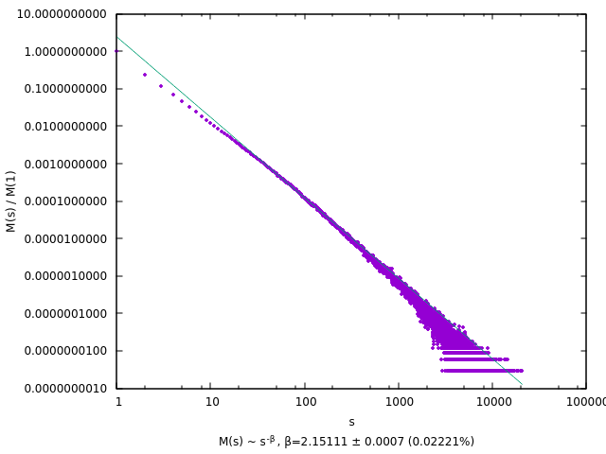Figure 4: Cluster size distribution
Figure 4 shows that this expectation was not unfounded. The distribution of tree clusters in the forest M(s) ~ s^{-β}, β ≈ 2.15 ± 0.0007 (0.02221%). As mentioned, this power law was investigated by Grassberger in [2], and the value reported by him is exactly 2.15.

What is also surprising is relatively few simulations need to produce this data. The line in a near perfect fit with very little fluctuations. In comparison with the fire size distribution, significantly fewer fires we burned.
Discussion:

The results produced in the first two simulations do seem to tend toward those produced by Grassberger in [2] and [3], however it is possible that all of these results are simply side effects stemming from the discrete nature of the simulations. These simulations took up to several hours to complete using the relatively small lattice size - Grassberger uses lattices of up to eight times the one used in these simulations – and it would have been unrealistic to attempt to use anything larger.

The number of fires burned in each case also, though rather large, still show fluctuations. Increasing these numbers greater than the ones used would likely produce results closer to the expected. Also, using a variety of θ values to further confirm these results would likely make them more convincing.

Since tree clusters in these simulations are burned down in their entirety, I would have expected the distribution of cluster sizes to be much similar to that of the fire sizes, however they are not even close (N(s) ~ s^{1-2.06194} = s^{-1.06194} vs M(s) ~ s^{-2,15}).

References:

- Drossel, B., & Schwabl, F. (1992). Self-organized critical forest-fire model. Physical review letters, 69(11), 1629.
- Grassberger, P. (1993). On a self-organized critical forest-fire model. Journal of Physics A: Mathematical and General, 26(9), 2081.
- Grassberger, P. (2002). Critical behaviour of the Drossel-Schwabl forest fire model. New Journal of Physics, 4(1), 17.
Software:

The software submitted with this report includes 4 files:

- ffm.h
- fire-time_sim.cpp
- fire-size_sim.cpp
- cluster-size_sim.cpp

The header file ffm.h defines the Forest object, which provides the methods for performing the simulations. The other three files are the simulations corresponding to the mean fire length simulation, the fire size distribution simulation, and the cluster size distribution simulation.

All three simulations use the Forest object as defined in ffm.h.

Due to the length of the software, the source code has not been attached. Instead I have emailed it to you as a zip file (matt-laidman_3p40-source-code.zip) as outlined in the project requirements.

The programs can be compiled and executed as follows:

- g++ -Ofast fire-time_sim.cpp -o fire-time_sim
./fire-time_sim 1> fire-times.dat

- g++ -Ofast fire-size_sim.cpp -o fire-size_sim
./fire-size_sim 1> fire-sizes.dat

- g++ -Ofast cluster-size_sim.cpp -o cluster-size_sim
./cluster-size_sim 1> cluster-sizes.dat

The software was written and executed on a 64-bit Linux machine using GCC 6.3.1. None of the simulations execute in a timely manner.

